Informatics Institute of Technology

In Collaboration With

University of Westminster, UK



*University of Westminster, Coat of Arms*

Generalized Abstractive Text Summarization Using Optimized Transformers

A Project Proposal by

Mr. Nazhim Kalam

w1761265 / 2019281

Supervised by

Mr. Torin Wirasingha

September 2022

This Project Proposal is submitted in partial fulfilment of the requirements for

the BSc (Hons) Computer Science degree at

the University of Westminster.

Table of Contents

List of Figures ii

List of Tables ii

1. Introduction 1

2. Problem Domain 1

2.1 Movie User Reviews 1

2.2 Text Summarization 2

2.3. Transformers 2

3. Problem Definition 2

3.1. Problem Statement 3

4. Research Motivation 3

5. Existing Work 3

6. Research Gap 7

7. Research Contribution 7

7.1. Technological Contribution 7

7.2. Domain Contribution 8

8. Research Challenge 8

9. Research Questions 8

10. Research Aim 9

11. Research Objectives 9

12. Project Scope 12

12.1. In-Scope 12

12.2. Out-Scope 12

12.3. Prototype Diagram 13

13. Proposed Methodology 13

13.1. Research Methodology 13

13.2. Development Methodology 14

13.2.1. Life Cycle Model 14

13.2.2. Design Methodology 14

13.2.3. Development Methodology 14

13.2.4. Requirement Elicitation Methodology 15

13.2.5. Evaluation Methodology 15

13.3. Project Management Methodology 15

13.3.1 Schedule 16

13.3.2. Resource Requirements 18

13.3.3. Risk Management 19

13.4. Solution Methodology 20

13.4.1 Data Collection 21

13.4.2. Data Pre-processing 21

13.4.3. Data Analysis 22

13.4.4. Model Selection and Training 22

13.4.5. Model Evaluation and Deployment 22

References I

# List of Figures

Figure 12.1 - Prototype Feature Diagram (Self-composed) 13

Figure 13.1 - Gantt Chart 16

Figure 13.2 - Model development flow (Self-composed) 21

# List of Tables

Table 5.1 - Related work in abstractive text summarization 3

Table 11.1 - Research Objectives 9

Table 13.1 - Research Methodology 13

Table 13.2 - Deliverables and Dates 17

Table 13.3 - Risk Mitigation Plan 19

**Acronyms**

|  |  |
| --- | --- |
| AI | Artificial Intelligence. |
| DL | Deep Learning |
| GUI | Graphical user Interface |
| ML | Machine Learning |
| NLP | Natural Language Processing |
| ROUGE | Recall-Oriented Understudy for Gisting Evaluation. |
| BLEU | Continuous-time Recurrent Neural Network. |
| T5 | Deep Learning. |
| BART | Graphics Processing Unit. |
| BERT | Long Short-Term Memory. |
| PEGASUS | Liquid Time-constant. |
| ILP | Machine Learning. |
| LSTM | Symmetric Mean Absolute Product Error. |
| RNN | Mean Absolute Scaled Error. |
| CNN  SEQ2SEQ | Mean Squared Error.  Sequence to Sequence |
| RoBERTa | Robustly Optimized BERT Pre-training Approach |
| GPT-3  REST | Third Generation Generative Pre-Trained Transformer  Representational State Transfer |

# 1. INTRODUCTION

In this research project, the author tries to increase the performance of abstractive text summarization for the domain of movie reviews but yet creating a generalized optimized solution which can be applied to various other domains aswell, by performing hyperparameter optimization on a set of top tiers pretrained transformer architectures, in-order to achieve an optimized architecture.

This document will discuss the research problem, research gap, research challenge, and the research approach that the author aims to address over the next months. Additionally, a review of prior research interests and the essential evidence of the issue is done. Finally, in the work plan, the expected schedule of the project’s deliverables is presented.

# 2. PROBLEM DOMAIN

## **2.1 Movie User Reviews**

A growing number of websites, like Amazon and the Internet Movie Database (IMBD), a website for movie reviews, allow users to publish reviews for things they are interested in, along with the growth of Web 2.0, where user interaction is prioritized. (Khan, Gul, Zareei, et al., 2020)

Online movie reviews are evolving into an important information source for users, with the continuous increase in data on the web (M and Mehla, 2019). However, online users post a significant number of movies reviews every day, hence making it difficult for them to manually summarize the reviews and determine their interest in the film. One of the challenging problems in natural language processing is mining and summarizing movie reviews. (Khan, Gul, Uddin, et al., 2020).

Text summary assist users or business decision-makers by compiling and analyzing a significant number of online reviews. (Alsaqer and Sasi, 2017).

These days, the majority of people research a film's reviews before selecting or watching it on any platform, such Netflix or Amazon Prime, but we also come across conflicting reviews that can be either good or bad. While most reviews are detailed and require a significant amount of time to review, this develops a problem where users aren't able to make quicker decisions. Therefore, by summarizing the review makes it easier and faster for users to make decisions. This can also help streaming services like Netflix quickly discover the viewing habits or preferences of their users (Dashtipour et al., 2021)

## **2.2 Text Summarization**

Today, there is a lot of textual material available, including news stories and reviews. Text summarizing helps us quickly find the key elements of the full piece by minimizing the quantity of text. (Mahajan et al., 2021).

Extractive summarization and abstractive summarization are typically the two methods of text summarization. When extractive summarizing, the most important lines from the context or article are plucked out without being altered in any way. Meanwhile, abstractive summarizing aims to create the sentences on its own and creates the summary; this is superior than extractive summarization since it is more meaningful to generate our own phrases inside the context rather than to utilize selected sentences from the context without any change. (Etemad, Abidi and Chhabra, 2021).

## **2.3. Transformers**

Transformers in NLP is a novel architecture that aims to solve sequence-to-sequence tasks while handling long range dependencies with ease. It has surpassed competing neural models like CNN (Convolutional Neural Nets) and RNN (Recurrent Neural Nets) in terms of performance to appear as the dominant architecture for natural language processing (Wolf et al., 2020).

Transformers uses self-attention mechanism to target on selected areas of the input sentence followed by the encoder and decoder architecture (Etemad, Abidi and Chhabra, 2021).

# 3. PROBLEM DEFINITION

In the domain of movie review summarization, currently there are no researches done using the latest deep learning approaches (**such as Transformers**) to solve this problem, standard machine & deep learning algorithms such as Naïve Bayes, RNN have been used, the usage of advanced deep learning approaches can be utilized in order to enhance the quality/accuracy of the text summarization.

Deep learning models take longer to train but they provide greater accuracy since they can simultaneously automate feature extraction and classification, whereas machine learning algorithms require feature selection at first. Therefore, applying deep learning techniques will help to improve the quality of text summarization and help the user in making better decisions (Etemad, Abidi and Chhabra, 2021).

## **3.1. Problem Statement**

The use of advanced deep learning approaches (such as Transformers) to generate abstractive summaries from movie reviews has not been investigated before, which can help in increasing the quality of text summarization. (Khan, Gul, Zareei, et al., 2020)

# 4. RESEARCH MOTIVATION

The identified problem can also be applied to several other domains which requires to improve the quality abstractive text summarization using the advanced approaches of deep learning, not only specific movie reviews, this is why a generalized solution was thought of initially (Kouris, Alexandridis and Stafylopatis, 2019).

As mentioned in the work of (Etemad, Abidi and Chhabra, 2021), syntactic and semantic issues with text summarization were the main issues that researchers were concerned on solving. and with respect to their research by exploring multiple deep learning techniques, they concluded that Transformer based models (T5 model) outperformed in all NLP tasks, this encourages the author to go deeper into the field of transformers optimization in order to enhance the quality of text summarization and address the constraints associated with the summarizing of movie reviews.

# 5. EXISTING WORK

Table 5.1 - Related work in abstractive text summarization

|  |  |  |  |  |
| --- | --- | --- | --- | --- |
| **Citation** | **Summary** | **Limitations** | **Contribution** | **Critical Review** |
| (Khan, Gul, Zareei, et al., 2020) | An automatic approach to summarize lengthy movie reviews and allow users to quickly recognize the positive and negative aspects of a movie. | To use advanced deep learning approaches. | Worked on feature extraction and converting reviews into vector space, followed by the Naïve Bayes machine learning algorithm used for review classification, using an undirected weighted graph based ranking algorithm to rank score for reach review sentence in graph. Finally, the top ranked sentences are chosen based on highest rank scores to produce **extractive summary.** | Only used general machine learning algorithms to handle movie review summarization not deep learning approaches. |
| (Boorugu, Ramesh and Madhavi, 2019) | Using customer reviews on products when making purchasing decisions to give a proper summarization of the reviews to the customer, so that he doesn’t need to go through all the reviews to figure out if the product is what he is looking for and save time. | Focused on improving the accuracy by using the latest models in the field of text summarization. By using transformers architecture, we could improve this. | Using seq2seq model for summarization along with attention mechanism for increased accuracy, also using word embedding model Concept net Number batch which is better than Glove. Finally, using a 1D convolutional layer followed by max pooling layer, LSTM layer and then at the end a fully connected layer. | Used general deep learning approaches such as RNN etc.… to solve the problem |
| (Mukherjee et al., 2020) | A solution for generating personalized aspect-based opinion summaries from large collections of online tourist reviews, also able to customize the attributes of the summary based on the user’s interest. | Motive for the need to create tourist review dataset for our experiments.  The need for also experimenting with the data of lesser known places (Tourist locations) | Using an Integer Linear Programming (ILP [Unsupervised method]) based extractive technique to select an informative subset of opinions around the identified aspects. Evaluate and compare the summaries using ROUGE based metrics and obtain competitive results. | Creating extractive summaries may not be very meaningful since the dataset is also limited down, hence using abstractive approach would give better results |
| (Gupta et al., 2021) | A comprehensive comparison of a few transformer architecture based pre-trained models for text summarization. | Future work should focus on building more robust models which can further extend the algorithm to create summaries of variable length and apply for multi-document summarization. | Using the pretrained models such as Pipeline BART, BART modified, T5 and PEGASUS to work with the text summarization. Evaluation metrics we done using the ROUGE Scores. | The author has used the top tier transformer architecture during experimentation, however the hyperparameters used were default which could be improved by tuning to get a better result. |
| (Mahajan et al., 2021) | Generate a text summary along with proper grammar and no repeated words using the Encoder-Decoder model with the attention layer. | Real time training required if this is used in production, in order to train with the latest articles with time. | Developed an encoder-decoder model using Gated Recurrent Units and trained the model to generate abstractive summary from an article. | The author has made use of deep learning approaches to handle the problem, however with respect to the domain its not practical to use in production since real time trained is not yet implemented |
| (Etemad, Abidi and Chhabra, 2021) | Experimenting the text summarization domain with deep learning approaches and finding which performs the best, from RNN, CNN, Transformers etc.… | NA | Experimenting with RNN based models’ architectures, working with pre-trained transformer-based model architectures. Finally, using evaluation metrics such as BLEU and ROUGE to evaluate the models. | The author has experimented with the advanced deep learning approaches but failed to tune the hyperparameters for better result. |

# 6. RESEARCH GAP

Based on previous work done (Khan, Gul, Zareei, et al., 2020) related to abstractive text summarization on movie reviews, the literature identify for the need of using advanced deep learning approaches to improve the performance of text summarization for this movie domain over traditional machine learning approach.

This project focuses on Empirical gap in the Movie Domain, as well as Theoretical and Performance gaps in the area of transformer optimization. Transformers plays a major role in the field of deep learning especially at problems related to Natural Language Processing, by performing hyperparameter optimization on several transformer architectures we can contribute to the enhanced quality of abstractive text summarization and create a generalized model which can be adapted with the respective domains usage and improve the performance.

# 7. RESEARCH CONTRIBUTION

Improving the performance of an existing solution is very common in the field of data science, as we can explore new algorithms or fine-tuning existing algorithms to get better results. The contributions for this project can be classified as theoretical contributions and domain contributions.

## **7.1. Technological Contribution**

There are various deep learning techniques that can be used to handle abstractive text summarization, however with respect to previous researches done, (Zhang, Xu and Wang, 2019) it is found that ***transformers*** outperform most of the other deep learning approaches as of today but there was no more research on optimizing them for a much better performance.

This research will be focused on getting the best optimized transformer architecture from few of the top tier existing pre-trained model by fine-tuning and performing hyperparameter optimization (Liu and Wang, 2021), therefore we are able to maximize the performance of the recommended architecture. Additionally, it is believed that this study approach could be utilized in any field that utilizes abstractive text summarization transformers.

## **7.2. Domain Contribution**

Neural Networks makes up the backbone of deep learning algorithms which enables them to process complex unstructured data over normal means of machine learning algorithms (Mahajan et al., 2021). It is found that, the need for using advanced deep learning approaches has not been explored in the domain of movie review summarization.

Given that transformers perform well in this field, the proposed solution for this domain will be finding the recommended architecture along with hyper-parameter optimization, to reach its best performance. An additional contribution will be that, the proposed solution will be generalized to any other domain linked with the field of NLP text summarization.

# 8. RESEARCH CHALLENGE

The main objective of this research is to achieve the optimized transformer architectures for the field of NLP abstractive text summarization. Transformers were introduced in 2017 by a team at Google Brain and are the most used choice for NLP problems replacing RNN models, given that this architecture was introduced not much longer back brings to a point where there is a lack of research done in the area of transformer optimization for the purpose of abstractive text summarization. (Wolf et al., 2020). Therefore, finding the most recommended transformer architecture along with the optimal parameters becomes a challenge with very less resources to look up to.

Additionally, identifying suitable datasets for this domain (Movie Reviews Summarization) is challenging and necessitates a substantial amount of effort in data preprocessing where it is important since we are dealing with NLP and performance optimization related domain.

# 9. RESEARCH QUESTIONS

**RQ1:** What are the top tier transformer architectures widely used and know for NLP problems related to text summarization?

**RQ2:** How can a pretrained transformer architecture be fine-tuned to get the optimal hyper parameters?

**RQ3:** What kind of evaluations should we perform after fine-tuning to filter out the best transformer architecture?

**RQ4:** What expected metadata and data format to be required from the dataset as for the transformers?

# 10. RESEARCH AIM

***The aim of this research is to design, develop and evaluate the most optimized transformer architecture from a range of popularly used architectures by fine-tuning via hyperparameter optimization, therefore obtaining the recommended architecture's optimum performance for generalized abstractive text summarization.***

To further explain the objective, a fully working system that can be utilized to execute abstractive text summarizing based on the movie review provided as input will be created by this research project. The quality of the resulting text summary or performance optimization will be the main points of emphasis. To get the best result, the usage of data preparation, data analysis, conducting hyperparameter tuning, and evaluating the models will be investigated.

To confirm or disprove the selected hypothesis, the necessary information will be obtained and investigated, components will be built, and performance will be evaluated. Both a hosted server and a local browser will be able to execute the system for private or public usage. The data science models and their source code will be made accessible for future study and usage in a public repository. The information gleaned from the literature review will be published in a review paper.

# 11. RESEARCH OBJECTIVES

The completion of the resulting research objectives is expected to fulfill the aims and provide answers to the research questions listed above. These goals are benchmarks that must be achieved for the research to be considered successful.

Table 11.1- Research Objectives

|  |  |  |  |
| --- | --- | --- | --- |
| **Objective** | **Description** | **LO** | **RQ** |
| Literature Review | Complete a thorough critical review of earlier related work.  **RO1:** Make a preliminary investigation on existing abstractive text summarization using deep learning approaches.  **RO2:** Make a preliminary investigation on why transformers architecture was the chosen deep learning choice for this research.  **RO3:** Analyze the top tier transformer architectures widely used.  **RO4:** Analyzing how the models can be fine-tuned via hyperparameter optimization.  **RO5:** Analyzing the different approaches used for model evaluation. | LO1, LO6 | RQ1,  RQ2,  RQ3 |
| Requirement Analysis | Defining the project's needs utilizing relevant approaches and tools in order to solve the projected research gaps and obstacles based on prior related research.  **RO1:** Gathering information related to the expected metadata required for the dataset to contain for the model training.  **RO2:** Gathering the requirements of transformer architectures for fine-tuning and understand the end to end user expectations.  **RO3:** Getting insights from domain experts to build a suitable system. | LO2,  LO3,  LO4,  LO5,  LO6 | RQ4,  RQ2,  RQ1 |
| Design | Considering the following when developing the suggested system:  **RO1:** Design a component to preprocess the dataset for the respective model inputs.  **RO2:** Design a component to store the top tier transformer models with their respective metadata, to use throughout.  **RO3:** Design a hyperparameter tuning component that can improve accuracy of the transformer model.  **RO4**: Design high-level architecture for the system. | LO3,  LO4,  LO6 | RQ2 |
| Development | Setting up a mechanism capable of addressing the gaps that were intended to be covered.  **RO1**: To develop data preprocessing component.  **RO2**: To develop a component that handles and stores the top tier transformer architectures for fine-tuning.  **RO3**: To develop the hyperparameter tuning component that handles all the top tier architectures assigned.  **RO4**: To develop a component for the model evaluations for the measured hyperparameters | LO3,  LO4,  LO6 | RQ2,  RQ3 |
| Testing and Evaluation | Testing and evaluating the developed system (including the data science models with the suitable metrices)  **RO1**: Performing unit test, integration and performance testing along with a test plan created.  **RO2**: Evaluating all the transformer architectures used for fine-tune experimentations, using recommended scores such as (ROUGE, BERT SCORE). | LO4,  LO6 | RQ3 |
| Documenting the progress | Keeping track of and documenting the study project's ongoing progress and any challenges encountered. | LO8, LO6 | - |
| Publish Findings | Ensure that the documentation, reports, and papers are well-structured and include a critical analysis of the research.  **RO1**: To publish a research paper on the related work done.  **RO2**: To publish the testing & evaluation results of the work done.  **RO3**: To publish the code implementation repository as public to be access by future research investigations, along with the models and datasets | LO4,  LO8 | - |

# 12. PROJECT SCOPE

The aim of this project to maximize transformers optimization by hyperparameter tuning, given below are the following scope details for the project objectives to be achieved, along with the review of existing solutions and with the time period taken into consideration.

## **12.1. In-Scope**

The project's scope is as follows:

* ***Recreating a usable dataset for the project*** – Reconstructing the dataset to a format structure which can be used for model training.
* ***Model refinement on hyperparameter tuning*** – Performing hyperparameter tuning on the top tier transformer architecture models*.*
* ***Evaluating the models*** – Evaluating all the architectures using appropriate metrics to filter out the best architecture from the rest*.*
* ***API integration development*** – REST API endpoints will be created to serve/call the final chosen model for interactions.
* ***GUI development*** – A graphical user interface will be developed; therefore, the end user will be able to perform abstractive text summarization and get visual results.
* ***Handling the generalization aspect of the model*** – Every (new) application user will be considered as a new domain user for the model creation, and will be tuning their specific set of hyper-parameters to support generalization.

## **12.2. Out-Scope**

The project will not include the followings:

* ***Limited architecture explored –*** The system will only be explored with few of the top tier architectures (roughly around 3 or 5 maximum), and will not be exploring more than that.
* ***Only single model integration–*** The final model which outperforms the rest with the best set of hyperparameters will be used as the summary generation model, options to select other architectures explored with their hyperparameters aren’t included.

## **12.3. Prototype Diagram**

Figure 12.1 - Prototype Feature Diagram (Self-composed)

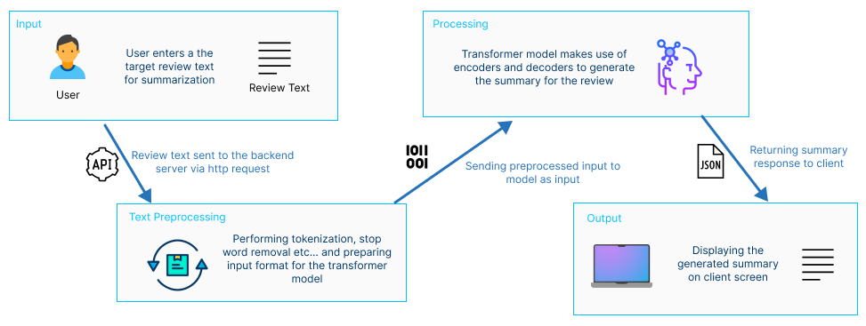

# 13. PROPOSED METHODOLOGY

## **13.1. Research Methodology**

When determining the quality of a project, there are a number of important factors to consider, including the cost incurred, the amount of time required, and the weight given to the project's scope. These factors must be effectively managed throughout the project's lifespan, which is when methodologies are required.

The table listed below are the chosen methodologies for the project, where Saunders Researched Onion model has been used (Saunders, Lewis and Thornhill, 2007).

Table 12.1 - Research Methodology

|  |  |
| --- | --- |
| Research Philosophy | The author will explore and experiment with numerous techniques as part of a combined strategy to determine which is most effective for reaching the research aim, therefore the **pragmatism** approach was chosen among the positivism, pragmatism, realism, and interpretivism approaches. |
| Research Approach | This research experiments with several approaches to figure out the best, the **deductive approach** was taken into consideration this was because the research aims at applying a combination of existing model architectures to fine-tune and get the best. As the data analysis **qualitative method** were chosen. |
| Research Strategy | This area focuses on data collection with respect to the research questions created. S**urvey and experiments** were the strategies considered to address the research questions. Both of these strategies are expected as an approach for the **quantitative result** at evaluation. |
| Research Choice | Weather the research is concerned with qualitative or quantitative aspects depends on the choice of methodology.  Even though we ultimately prioritize quantitative findings mainly, **multi-method** was taken into consideration for this study. This is partly because determining the qualitativeness of the data utilized for development is important since, in the end, it will influence the quantitative outcomes. |
| Time Horizons | **Cross-sectional** will be used since only during the requirement engineering and evaluation phase the data will be gathered and therefore not repeatedly collection over time. |
| Techniques and procedures | Here, data collecting and analysis methods are considered.  We'll utilize sources including internet news, discussions, reports, surveys, publications and organizational records. |

## 

## **13.2. Development Methodology**

### **13.2.1. Life Cycle Model**

The project's research development methodology of choice was the **Agile** Software Development Life Cycle. This is a result of the project's reliance on an iterative development method.

### **13.2.2. Design Methodology**

Modularity for flexibility and Code Reusability for efficiency and future development continuity was considered by the author to support incremental methodology, hence **Object-Oriented Analysis and Design** was chosen as the Design Methodology for the project.

### **13.2.3. Development Methodology**

**Object oriented programming** methodology will be used for the development methodology for the project, this is due to the project's ease of future developer enhancement, making it simpler.

### **13.2.4. Requirement Elicitation Methodology**

Conducting Surveys via questionnaires, review more previous research done, experimenting with various transformer architectures and brainstorming will be the approaches taken in-order to communicate and gather **insights** for the projects need.

### **13.2.5. Evaluation Methodology**

**Prototype testing**

A set of test cases will be created in order to test out the entire flow of the prototype with respect to the actual output and whats expected.

**Model testing**

With respect to previous research done (Steinberger and Jezek, 2009) states that for text generated/summarization evaluations using **ROUGE** score demonstrate the best performance compared to other available evaluation methods such as **BLEU**. Therefore, **ROUGE** will be used as the evaluation metric for this project. (Lin, 2004)

**Benchmarking**

Performance benchmarking is necessary to assess the model's effectiveness on a test data set that replicates the production data, as well as its output speed and memory consumption. Benchmark testing will be done on the final model architecture, which will serve as the optimized model, meanwhile ROUGE will be used for the model evaluation (Steinberger and Jezek, 2009) .

## **13.3. Project Management Methodology**

By organizing activities on a **Kanban** **board**, where workflow and progress are visible to all, the Kanban methodology, a visual approach to project management, helps manage workflow. This will be the project's selected project management methodology since it allows for tracking of the stages, deadlines, and other information that the project represents on a board.

### **13.3.1 Schedule**

**Gantt Chart**

Figure 13.1 - Gantt Chart

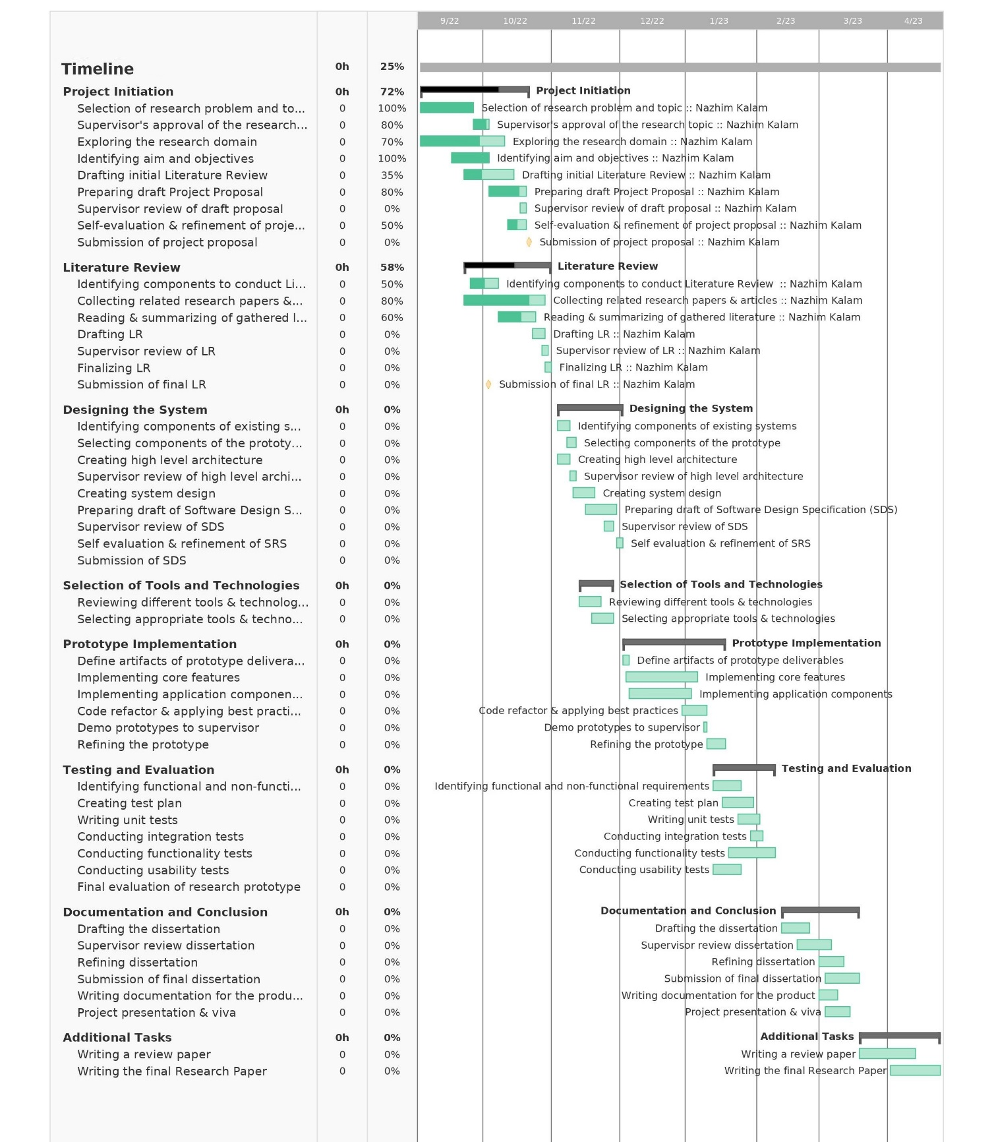

**Deliverables**

Table 13.2 - Deliverables and dates

|  |  |
| --- | --- |
| Deliverable | Date |
| **Project Proposal Document + Ethics Forms**  Initial proposal of the project. | 3rd November 2022 |
| **Software Requirement Specification**  Documentation outlining the requirements that must be met, designed as the ultimate prototype, including data collection methods. | 24th November 2022 |
| **Proof of Concept with Implementation Presentation**  Performing a presentation regarding the implementation along with the proof of concept | 23rd December 2022 |
| **Project Specifications Design & Prototype**  A functional prototype with all its main features included as stated. Along with a documentation of the design approach followed. | 2rd February 2023 |
| **Test & Evaluation Report**  Documented Evaluation Report conducted on the Prototype. | 23rd March 2023 |
| **Draft Project Proposal**  A draft thesis submission, in order to get supervisors feedback | 30th March 2023 |
| **Final Thesis**  Final report detailing the research and project decisions | 27th April 2023 |
| **Review Research Paper**  A review paper reviewing published existing systems in handling abstractive text summarization. | 2nd May 2023 |
| **Final Research Paper**  A research paper about the experimentations done with the transformers hyperparameters. | 15th May 2023 |
| **Public project repository**  A publicly accessible project repository to setup and test the development | 30th April 2023 |

### 

### **13.3.2. Resource Requirements**

**Software Requirements**

* ***Operating System* –** Microsoft Windows OS will be used for the research, documentation and for the complete project implementation (end to end), due to its fexilibility compared to other operating system.
* ***Python* –** Machine learning & Deep learning model development and APIs creation to serve the models and handle logic will be implemented by using the Python language. Python is a general-purpose language that has been used most widely in data-science related projects and in backend frameworks link Flask and Django.
* ***Flask* –** Backend web framework for API development for the prototype. This will be used to access/transfer data to and from the data science models developed.
* ***TensorFlow/ Scikit learn Python packages* –** Libraries that will be used during the development of the data science models.
* ***Jupyter Notebook / Google Colab* –** Used for Machine-learning/Deep learning model development in this project, it’s an Integrated development environment for programming.
* ***TypeScript (React)* –** JavaScript framework which is used for the development of the frontend application interface of the project. Here is where the user will be able to input and view their data.
* ***Vscode* –** The project's development environment. This will be utilized while creating the codebase for the backend API and frontend development.
* ***Zotero* –** Referencing software that keeps a copy of all the articles as well as managing the references for research papers
* ***MS Office/ Google Docs/ Figma* –** Software & tools which will be used to create figures, reports and handle documentations.
* ***Google Drive/ GitHub* –** Backup platform and code management system to help keep backup of all documents and code.
* ***Git* –** Version control system which will be used to keep track of the changes made in the project code and manage code changes.
* ***Firebase* –** Application development platform which helps to build and grow apps, its also known as the Backend As a Service.

**Hardware Requirements**

* **Core i5x Processor (8th generation) or above –** Above average processing power required to perform high resource intensive tasks (such as model training).
* **Nvidia MX130 GPU or above –** To handle data science model training processes.
* **16GB RAM or above –** Sufficient amount of RAM needed to run multiple applications (client + server), model training also consumes a lot of CPU and RAM.
* **Disk space of 30GB or above –** To store project data and applications.

**Data Requirements**

* Amazon Movie review data **–** From Stanford University Education.

**Skill Requirements**

* Good understanding about machine learning and deep learning concepts.
* Good understanding about Natural Language Processing and its data preprocessing methods.
* Good understanding about transformers and how to work with hyperparameters in general along with the knowledge of its use.
* Research writing skills

### **13.3.3. Risk Management**

The table given below defines the possible risks which can be encountered during the process of the project development along with the possible mitigation steps.

Table 13.3 - Risk Mitigation Plan

|  |  |  |  |
| --- | --- | --- | --- |
| Risk | Magnitude of the loss | Probability of occurrence | Mitigation Plan |
| Losing the development project codebase/repository | 5 | 2 | Using GitHub and external backup to keep a latest copy of the project codebase. |
| Project documentation corruption | 5 | 4 | Use a dedicated folder under the same GitHub repository and push all latest documentation changes & use cloud-based documentation approach |
| Unable to complete all mentioned project deliverables on time | 4 | 2 | Prioritize and create a timeline to complete the deliverables. |
| Insufficient knowledge on the project domain | 5 | 3 | Performing an intensive research on the problem domain along with the research domain. |
| Personal computing breaks down during the project timeline progress. | 5 | 4 | Upload the complete backup to GitHub and Google Drive, use University Lab service to continue project work, till personal machine recovery. |
| Any unavoidable personal health risk – Sickness | 3 | 1 | Create weekly goals to complete and keep them updated. |

## 

## **13.4. Solution Methodology**

Data collection, data preprocessing, data visualization, model training, model evaluation, and model deployment are the main phases that all machine/deep learning model developments go through. Regarding a few earlier studies on transformers, the author followed the general principles and experimented with a variety of pre-trained transformer models in order to determine which performs the best ( Ashmore, Calinescu and Paterson, 2019). The same process will be followed in this project, but the phase for tweaking the hyperparameters will be included as an extra step.

Figure 12.2 – Model development flow (Self-composed)

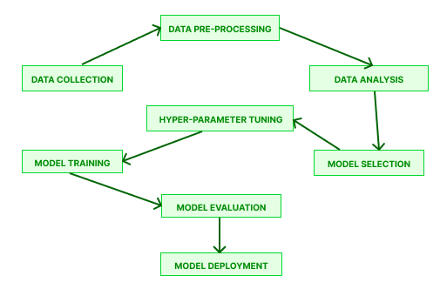

### **13.4.1 Data Collection**

Data gathering techniques often fall into one of two categories: primary or secondary. In contrast to secondary data collecting methods, which use data that has already been gathered, primary data refers to information that was obtained directly by the researcher (Devi and Pavithra, 2022). Secondary data gathering is the method utilized in this project.

### **13.4.2. Data Pre-processing**

This step involves in preparing the data before it is subjected to the training processing by using a series of techniques as follows:

* ***Lower casing***: Creating a common casing out of every text context.
* ***Punctuation removal***: Remove any characters that don't have significant meaning.
* ***Stopwords removal***: Elimination of terms that are used frequently but don't add much sense to the context, such "the" and "a".
* ***Contraction mapping***: Adding more detail to abbreviated words like "don't" into "do not".
* ***Stemming***: A method of reducing a word to its word stem.
* ***Lemmatization***: Grouping different inflected of words into the root form.

### **13.4.3. Data Analysis**

This procedure, also known as data visualization, involves graphically depicting the data (using maps, graphs, and charts) and identifying data patterns (Suresh and Guttag, 2021). Where necessary, data visualization will be used in this project.

### **13.4.4. Model Selection and Training**

The author will experiment with tuning hyperparameters while utilizing various pretrained model transformer architectures. This transformer architecture is the optimum option since it dominates the field of natural language processing. Using pertained model, the author is able to achieve stronger performance than creating a model from scratch as a result of their extensive corpus data training. (Wolf et al., 2020)

Since they are the top tier model architectures, the pre-trained models chosen for hyperparameter tweaking will include BART, T5, PEGASUS, RoBERTa, and GPT-3.

**Hyperparameter Optimization**

This set of parameters needs to be calculated for optimal performance, so model training parameters could be set to them. Minimizing the loss and cost has the potential to stabilize the bias and variance in the model (Liu and Wang, 2021; Joy and Selvan, 2022). Additionally, the chosen dataset will have an impact on the estimated set of hyperparameters.

### **13.4.5. Model Evaluation and Deployment**

There are several forms of evaluation metrics for text summarization models, including **BLEU** and **ROUGE**. Since **ROUGE** is more credible than **BLEU**, it will be utilized for model evaluation and choosing the optimal model architecture to apply. (Steinberger and Jezek, 2009)

The model deployment will be done together with the backend server and hosted in cloud platforms.

# REFERENCES

Alsaqer, A.F. and Sasi, S. (2017). Movie review summarization and sentiment analysis using rapidminer. *2017 International Conference on Networks & Advances in Computational Technologies (NetACT)*. July 2017. Thiruvanthapuram, India: IEEE, 329–335. Available from https://doi.org/10.1109/NETACT.2017.8076790 [Accessed 10 October 2022].

Boorugu, R., Ramesh, G. and Madhavi, K. (2019). Summarizing Product Reviews Using Nlp Based Text Summarization. *International Journal of Scientific & Technology Research Volume*, 8 (10), 1127–1133.

Dashtipour, K. et al. (2021). Sentiment Analysis of Persian Movie Reviews Using Deep Learning. *Entropy*, 23 (5), 596. Available from https://doi.org/10.3390/e23050596.

Devi, A. and Pavithra, K. (2022). Machine Learning: Life Cycle and its Techniques. *SSRN Electronic Journal*. Available from https://doi.org/10.2139/ssrn.4140255 [Accessed 25 October 2022].

Etemad, A.G., Abidi, A.I. and Chhabra, M. (2021). A Review on Abstractive Text Summarization Using Deep Learning. *2021 9th International Conference on Reliability, Infocom Technologies and Optimization (Trends and Future Directions) (ICRITO)*. 3 September 2021. Noida, India: IEEE, 1–6. Available from https://doi.org/10.1109/ICRITO51393.2021.9596500 [Accessed 10 October 2022].

Gupta, A. et al. (2021). Automated News Summarization Using Transformers. *ArXiv*, abs/2108.01064.

Joy, J. and Selvan, M.P. (2022). A comprehensive study on the performance of different Multi-class Classification Algorithms and Hyperparameter Tuning Techniques using Optuna. *2022 International Conference on Computing, Communication, Security and Intelligent Systems (IC3SIS)*. 23 June 2022. Kochi, India: IEEE, 1–5. Available from https://doi.org/10.1109/IC3SIS54991.2022.9885695 [Accessed 24 October 2022].

Khan, A., Gul, M.A., Zareei, M., et al. (2020). Movie Review Summarization Using Supervised Learning and Graph-Based Ranking Algorithm. *Computational Intelligence and Neuroscience*, 2020, 7526580. Available from https://doi.org/10.1155/2020/7526580.

Khan, A., Gul, M.A., Uddin, M.I., et al. (2020). Summarizing Online Movie Reviews: A Machine Learning Approach to Big Data Analytics. *Scientific Programming*, 2020, 1–13. Available from https://doi.org/10.1155/2020/5812715.

Kouris, P., Alexandridis, G. and Stafylopatis, A. (2019). Abstractive Text Summarization Based on Deep Learning and Semantic Content Generalization. *Proceedings of the 57th Annual Meeting of the Association for Computational Linguistics*. 2019. Florence, Italy: Association for Computational Linguistics, 5082–5092. Available from https://doi.org/10.18653/v1/P19-1501 [Accessed 24 October 2022].

Lin, C.-Y. (2004). ROUGE: A Package for Automatic Evaluation of Summaries. 8.

Liu, X. and Wang, C. (2021). An Empirical Study on Hyperparameter Optimization for Fine-Tuning Pre-trained Language Models. Available from http://arxiv.org/abs/2106.09204 [Accessed 24 October 2022].

M, M. and Mehla, S. (2019). Sentiment Analysis of Movie Reviews using Machine Learning Classifiers. *International Journal of Computer Applications*, 182 (50), 25–28. Available from https://doi.org/10.5120/ijca2019918756.

Mahajan, R. et al. (2021). Text Summarization Using Deep Learning. *International Research Journal of Engineering and Technology (IRJET)*, 08 (05th May 2021), 1737–1740.

Mukherjee, R. et al. (2020). Read what you need: Controllable Aspect-based Opinion Summarization of Tourist Reviews. *Proceedings of the 43rd International ACM SIGIR Conference on Research and Development in Information Retrieval*. 25 July 2020. 1825–1828. Available from https://doi.org/10.1145/3397271.3401269 [Accessed 10 October 2022].

Saunders, M.N.K., Lewis, P. and Thornhill, A. (2007). *Research methods for business students*, 4th ed. Harlow, England ; New York: Financial Times/Prentice Hall.

Steinberger, J. and Jezek, K. (2009). Evaluation Measures for Text Summarization. *Comput. Informatics*, 28 (2), 251–275.

Suresh, H. and Guttag, J.V. (2021). A Framework for Understanding Sources of Harm throughout the Machine Learning Life Cycle. *Equity and Access in Algorithms, Mechanisms, and Optimization*. 5 October 2021. 1–9. Available from https://doi.org/10.1145/3465416.3483305 [Accessed 25 October 2022].

Wolf, T. et al. (2020). Transformers: State-of-the-Art Natural Language Processing. *Proceedings of the 2020 Conference on Empirical Methods in Natural Language Processing: System Demonstrations*. 2020. Online: Association for Computational Linguistics, 38–45. Available from https://doi.org/10.18653/v1/2020.emnlp-demos.6 [Accessed 10 October 2022].

Zhang, H., Xu, J. and Wang, J. (2019). Pretraining-Based Natural Language Generation for Text Summarization. Available from http://arxiv.org/abs/1902.09243 [Accessed 25 October 2022].